Tomasz Maleszka – abstract of his PhD thesis
Title: Flexible antennas and antenna arrays operating in the vicinity of lossy media
Wroclaw University of Technology, Wroclaw 2012
supervisor: Pawel Kabacik

The thesis focuses on the key issues related to flexible and wearable antennas and their interactions with human body tissues. The objective of the research was to investigate the usability of antennas manufactured entirely with use of flexible and textile materials (both conductive and dielectric) within the body-centric wireless communication systems. Within the research period, several concepts of wearable antennas, as well as measurement techniques have been proposed.
The research activities have been divided into three following sections: (1) the characterization of electrical properties of textile/flexible materials, (2) wearable antenna development, (3) analysis of wearable antenna interactions with lossy media (human tissue).
The first part, devoted to the analysis of the selected textile materials, aimed at reliable characterization of electrical properties of textile and flexible materials, as well as evaluation of their usability in the development of antennas, operating within the range of 0.5-10 GHz. Several dielectric and conductive materials have been chosen. For the measurements of electric permittivity of textile dielectrics, the following materials have been investigated: cotton, polyester, felt, leather, technical foams, compound textiles. These materials have been tested with use of existing methods, namely: lumped capacitance method or perturbation method, as well as new, time-domain gating technique, dedicated to planar samples of low-loss dielectrics, has been proposed. The developed method makes use of time-domain measurements of input impedance of microstrip line manufactured on rigid substrate, with the sample of material-under-test situated on its surface. The accuracy of the method does not depend on the dimensions of the sample and offers wide-band measurement of dielectric constant of planar dielectrics having a thickness larger than 0.5mm. The values of permittivity measured with the time-domain method correspond to the results obtained with use of modified perturbation technique (X-band measurements). Conductive textiles, such as ShielditTMSuper, metalized polyamide grid or conductive woven/knitted fabrics have been characterized with use of waveguide transmission technique. The impact of detergents (washing) on material conductivity, as well as the influence of moisture on textile dielectric permittivity has also been analyzed.
The measured values of permittivity and conductivity have been used in numerical modeling tools, such as CST in the second stage of the thesis, devoted to the development wearable/flexible antennas and associated microwave circuits. Several technological approaches have been investigated, including direct embroidery of the textile circuit on fabrics, the use of sewing techniques, high temperature adhesives and laser treatment. A number of wearable antenna prototypes, operating within the frequency range of 0.5-5GHz have been developed with use of these techniques: embroidered dipoles, loop antennas, textile microstrip patch antennas, dual planar loop array and 2x2 circularly polarized textile antenna array. As dipole or loop antennas require symmetrical feeding – textile bypass MS-CPS balun has been proposed. Several microwave devices have been realized entirely with use of textile techniques: couplers, power dividers and impedance transformation circuits. The developed antennas and antenna arrays have been tested under bending conditions and the influence of the deformations on antenna properties have been identified (e.g. bandwidth and resonant frequency variations). As a result, the measures of antenna sensitivity and measurement repeatability have been proposed.
Designed and manufactured antenna models have been utilized in the final stage of the thesis, which involved the investigation of the influence of the presence of lossy media, namely human tissue, on the properties of wearable antennas. Firstly, several antennas have been selected for SAR assessment (measurements conducted at IMST, Germany in the frame of 7FP CARE project). The field distributions obtained during the SAR measurement procedure, along with impedance matching measurements as a function of antenna distance from TwinSAM phantom have been used to evaluate the antenna performance at close distance from the human body equivalent medium. Further, the farfield measurements of selected on- and off-body antennas have been conducted with use of SAM-Head phantom (antennas mounted in the neck region). Main phenomena associated with antenna radiation in the presence of lossy environment have been indentified (e.g. increase of directivity, efficiency degradation). Finally, the novel lightweight lossy mannequin has been proposed and validated in the measurements of antennas, mounted in the chest area. The new phantom makes use of dielectric shell, filled with wave-absorbing materials. This approach enables the spherical measurements of antenna radiation pattern in compact reflection chamber with use of large parts of human body, which would be extremely difficult with use of heavy, liquid phantoms. The measurements of most promising concepts of the developed antennas (e.g. textile circularly polarized 2x2 antenna array) with used of this phantom showed, that the most critical parameters (e.g. directivity direction of propagation, axial ratio) remain at satisfactory level. This proved their resistance to the presence of lossy media and their usability in a number of wireless, body-centric communication systems.
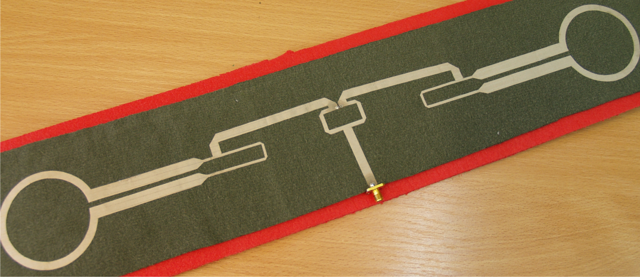
Fig. The manufactured prototype of dual loop textile antenna array: cotton substrate, f=1850MHz, element separation 450mm approx.

